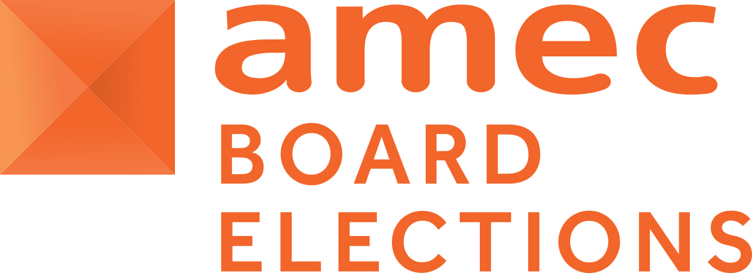
2021 AMEC Board Elections Official Ballot Paper
For the Board election of One ‘Individual Member’
The following 2 candidates have been validly nominated for election to the Board. As there is 1 vacancy we ask members to complete this ballot form to vote for your preferred candidate. Hyperlinks will enable you to review each candidate’s Nomination Form and Manifesto.

ONLY Individual Members can vote in this Ballot.
Please cast ONE vote for your ONE preferred candidate by entering ‘x’ in the appropriate column on the grid below, and forwarding the saved document via e-mail to juliewilkinson@amecorg.com on behalf of the two scrutineers (Johna Burke and Julie Wilkinson).

- Please complete by the deadline date of TUESDAY 1 DECEMBER 2020.
- Please provide your name and company you represent, if applicable below.

Name of representative completing the form:

Member grade of representative completing the form:

Candidate Name | Company | Links below to view:  Nomination and Personal Statement/Manifesto | YOUR VOTE (X)  Please vote by indicating X against your 1 selected candidate
- Steph Bridgeman | Founder and Lead Consultant, Experienced Media Analysts | - Nomination and Election Manifesto
- Liam Kelly | Founder, PR Measured | - Nomination and Election Manifesto

IMPORTANT NOTE TO THE BALLOT PROCESS
- Please CHECK CAREFULLY that your vote has been recorded properly as mistakes cannot be rectified after the ballot closes under any circumstances.
- Each Individual Member may submit only one completed ballot paper. This is a secret ballot and is confidential to the two scrutineers.

For validation of your vote please ensure you provide your name in the relevant field above.

Johna Burke Julie Wilkinson
Global Managing Director - Scrutineer Executive Assistant - Scrutineer

24 November 2020

